Assignment #5 — Forms and Validation
Objective:
The goal of this assignment is to learn how to create user-friendly forms using HTML and style them with Bootstrap.
Students also learn how to apply validation — both built-in HTML5 validation and Bootstrap validation classes.
Part 1 – Basic HTML Forms
Created a simple contact form with fields: Name, Email, Message, and Submit button.
All inputs have <label> elements.
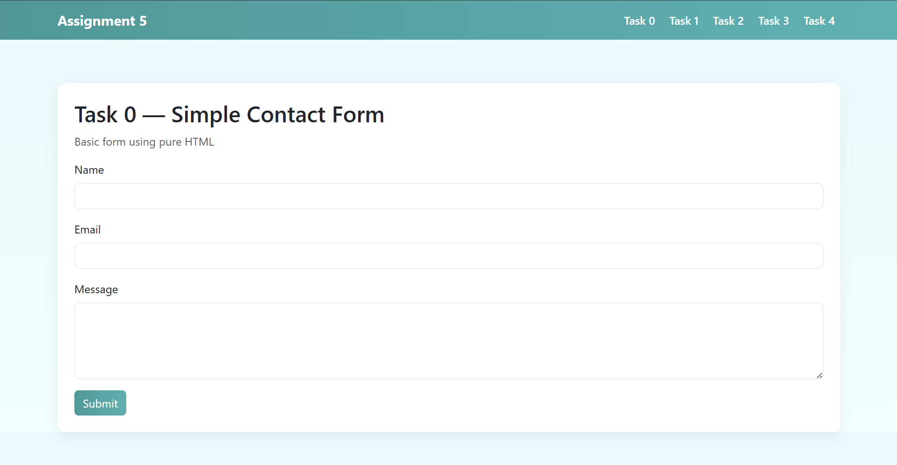
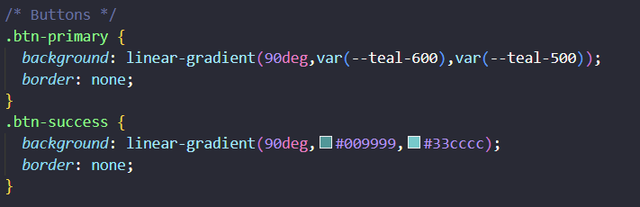

Task 1 – Form with HTML5 Validation
Added HTML5 attributes like required, type="email", and maxlength to enforce input validation.
The browser automatically checks the correctness of the data.
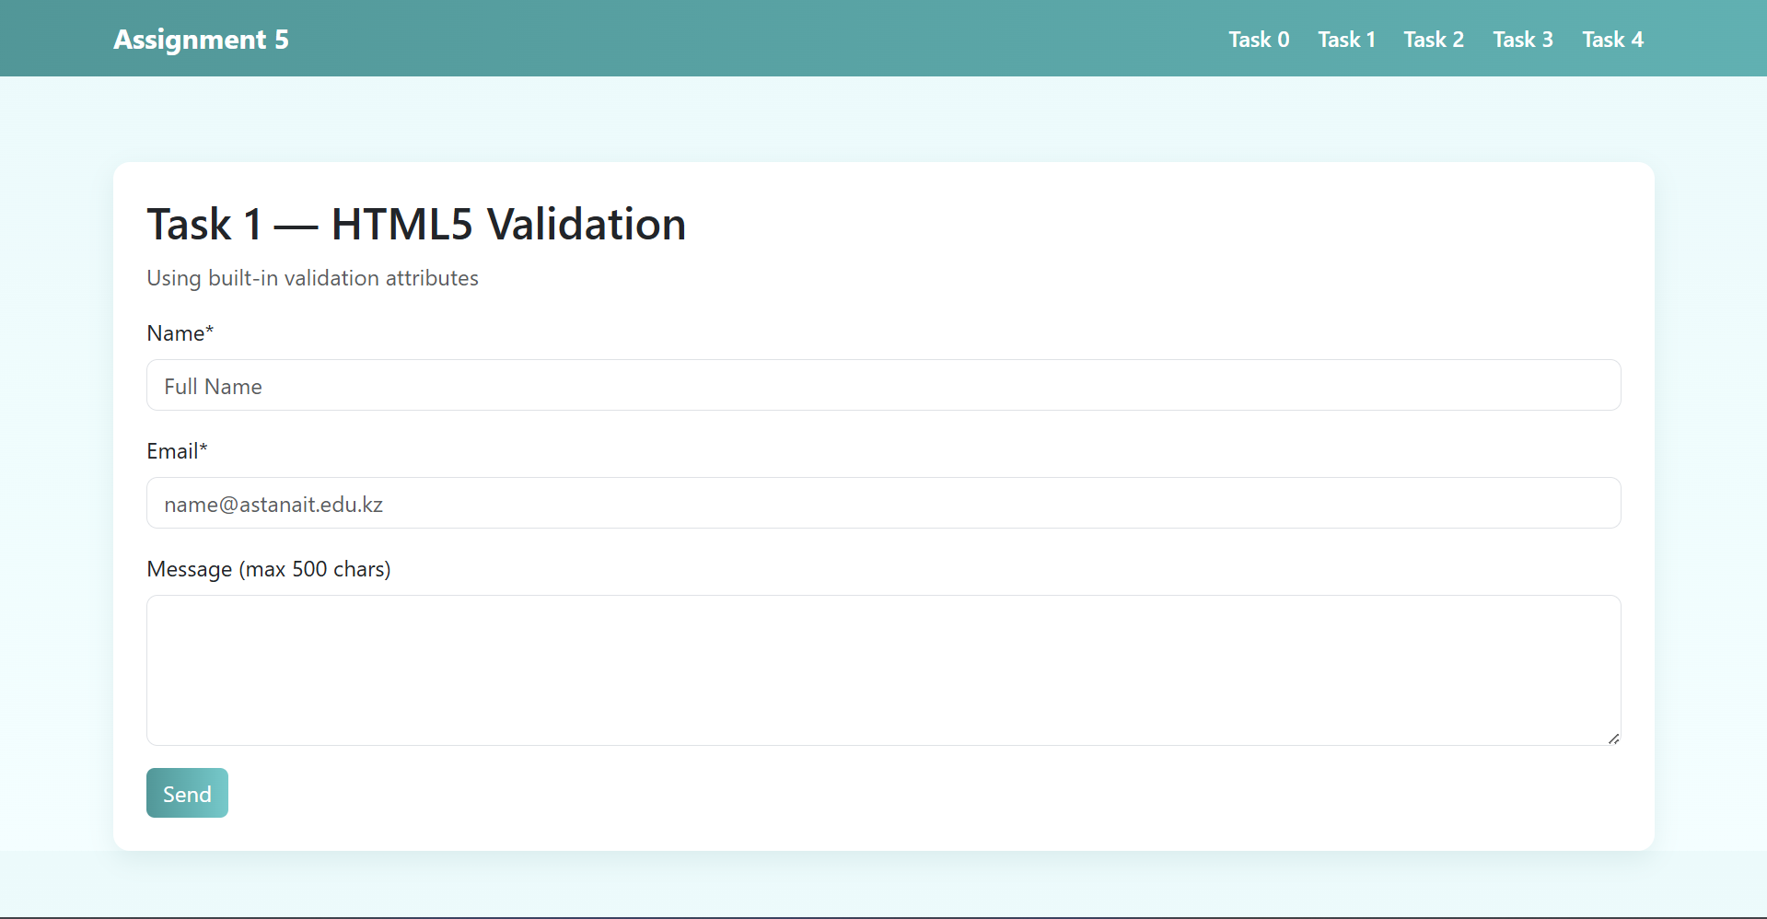
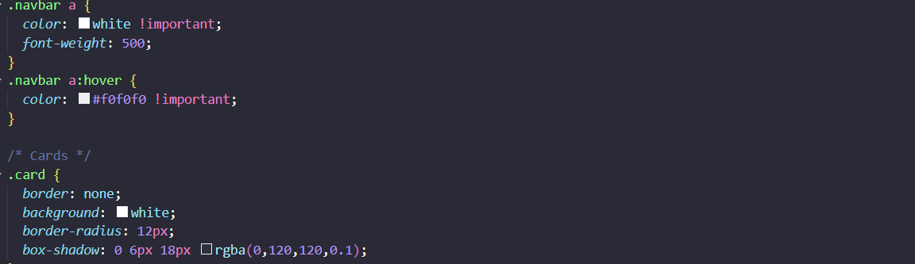
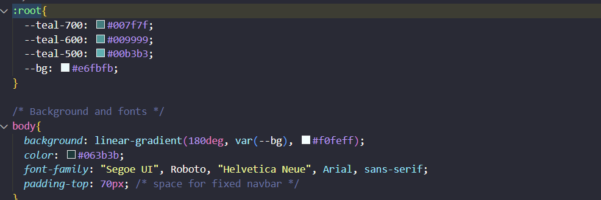
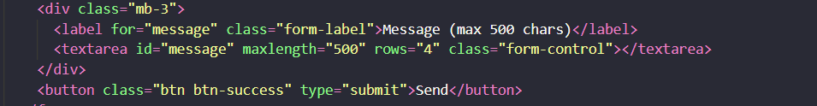
Part 2 – Bootstrap Forms
Recreated the contact form using Bootstrap form classes and grid system.
The layout became responsive and visually cleaner.
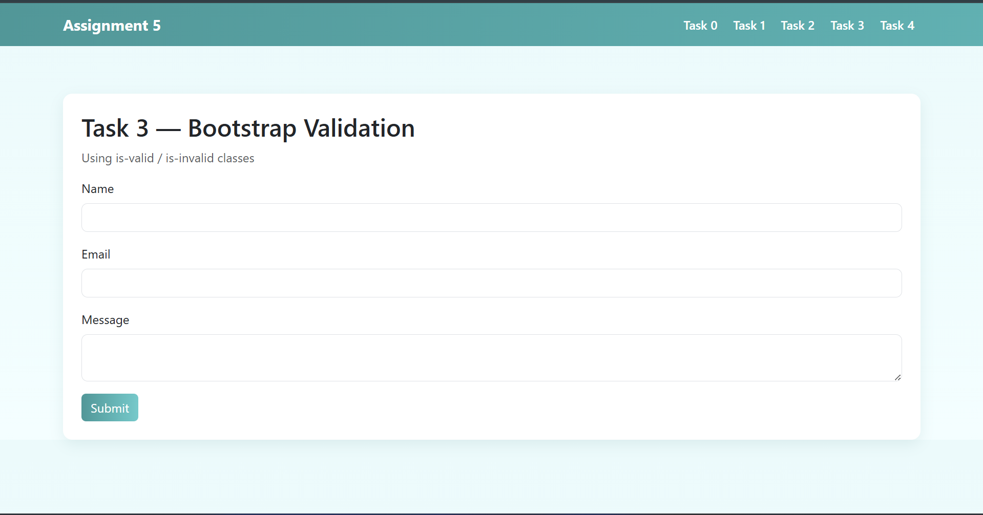
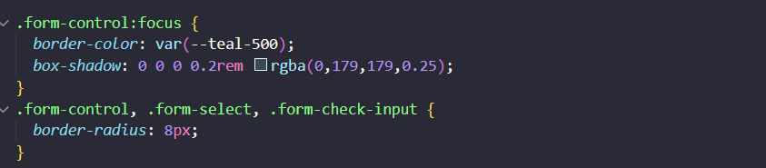
Part 3 – Registration Form
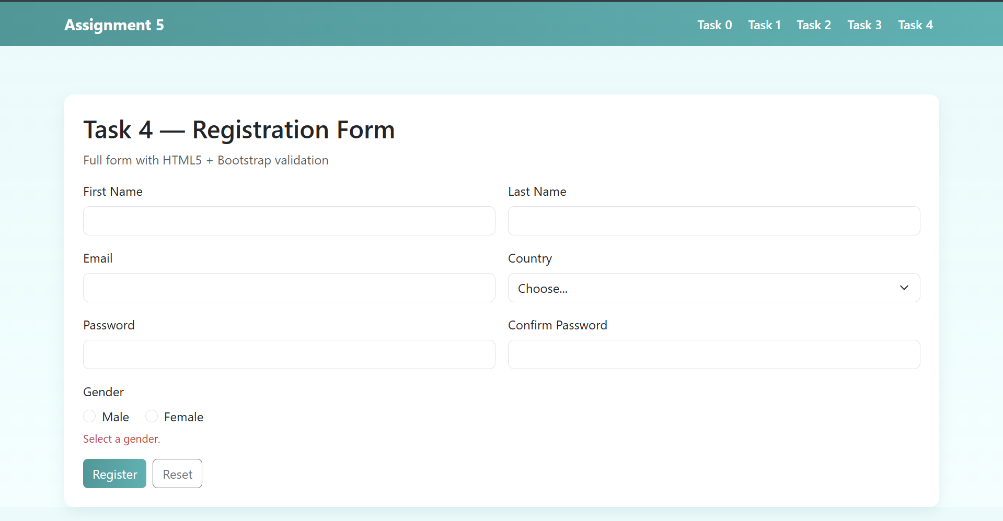
Created a complete registration form containing:
- First Name, Last Name
- Email
- Password and Confirm Password
- Gender (radio buttons)
- Hobbies (checkboxes)
- Country (dropdown)
Added HTML5 validation and Bootstrap validation feedback with JavaScript logic for checking password match.
The form is responsive and user-friendly.
Design & Features:
All forms share the same turquoise color theme defined in one CSS file.
The layout is responsive and uses a fixed top navigation bar for switching between tasks.
Summary:
This project helped me understand how to build structured and validated forms using HTML5 and Bootstrap.
I also learned how to add JavaScript logic for more complex validation cases (like matching passwords).
Conclusion:
The assignment improved my understanding of front-end development fundamentals, responsive design, and user input validation.
GitHub- https://github.com/XelVarful/Frontend.git

